AN
INTERNSHIP REPORT
ON
Food and Beverage Department, Himalaya Drishya Resort

By
Sabin Dahal
Roll No: 21155305
P.U Registration No: 2021-2-15-0863

An Internship Report Submitted to Pokhara University in partial fulfilment of the requirements for the degree of
Bachelor of Hotel Management

at the
Quest International College
Pokhara University
Gwarko, Lalitpur
23rd February 2026

INFORMATION SHEET

Name of the Company : Himalaya Drishya Resort
Address of the Company : Dhulikhel, Kavre
Phone Number of the Company : 011665343
Date of Internship Commencement : 27th March 2025
Date of Internship Completion :
Name of the Industry Guide : Mukunda Parajuli
Designation of Industry Guide : Shyam Kaji Mahat
Student’s Name : Sabin Dahal
Student’s e-mail ID : sabindahal100@gmail.com

DECLARATION

This Internship Report, titled “Internship Report on Himalaya Drishya Resort, Dhulikhel, kavre” submitted as part of the BHM degree requirements at Pokhara University, is a product of my independent effort. I confirm that the content is entirely original, and proper acknowledgment is given to any external materials referenced in the report.

………………………………
Sabin Dahal
23rd February 2026

LETTER OF RECOMMENDATION
This is to certify that the Internship Report entitled “Internship Report on Himalaya Drishya Resort, Dhulikhel, kavre ” submitted by Sabin Dahal is to fulfil the degree requirements, represents genuine and commendable work conducted under my guidance. I recommend this report for the final examination by the research committee of Quest International College, Pokhara University, towards the attainment of the Bachelor of Hotel Management degree.

………………………..
Mr. Abhishek Risal
Research Supervisor
23rd February 2026

RECOMMENDATION FOR APPROVAL
This is to certify that the Internship Report on ““Internship Report on Himalaya Drishya Resort, Dhulikhel, kavre” prepared submitted by Sabin Dahal for the partial fulfilment of the requirements for the degree of Bachelor of Hotel Management is found her original work. The report is, therefore, approved and recommended for its acceptance.

………………………………
Mr. Kolin Kiran Shrestha
Director
Quest International College

…………………………………
Mr. Udaya Raj Paudel
Principal
Quest International College

23rd February 2026

ACKNOWLEDGEMENT
In today's context, hands-on experience holds significant value as it enhances comprehension by actively engaging with concepts. I appreciate Pokhara University for affording us chances to participate in practical fieldwork. My gratitude extends to Quest International College for their unwavering support during my internship report as a part of accomplishment of BHM program.
I want to sincerely thank those who supported me in preparing this internship report. Special appreciation goes to Mr. Kolin Kiran Shrestha, the director at Quest International College, for securing such a great internship opportunity at Himalya Drishya Resort, Dhulikhel. My heartfelt thanks also go to the Research and Development Team at Quest for their constant assistance throughout the report preparation. Their invaluable suggestions and guidance were crucial in completing this report successfully.
I extend my gratitude to Mr. Shyam Kaji Mahat, Director of Guest Relation, for entrusting me with the internship at this esteemed organization. My heartfelt appreciation also goes to Mr. Mukunda Parajuli, Food and Beverage Manager, and my senior colleagues at Himalaya Drishya Resort for their wholehearted cooperation. The remarkable working atmosphere and collective commitment of the team significantly contributed to my learning and observation of hospitality operational activities throughout the five-month internship period.
I want to express my appreciation for the unwavering support of my friends and family. Their encouragement has been pivotal in boosting my confidence to compile this report. I am thankful for their years of dedicated time and effort, and this page serves as a tribute to these invaluable individuals who played a crucial role in the successful completion of the final report.

Sabin Dahal
23rd February 2026

Table of content
DECLARATION 3
LETTER OF RECOMMENDATION 4
RECOMMENDATION FOR APPROVAL 5
ACKNOWLEDGEMENT 6
Table of Figure 9
CHAPTER 1: ORGANIZATION PROFILE 10
1.1 Introduction to Himalayan Drishya Hotel 10
Drishya Restaurant 13
Outdoor Pool Bar 14
Gauri Shankar Ballroom 16
1.2 Organization Vision, Mission and Objectives 18
Vision 18
Mission 18
1.3 Organization Design and Structure 19
1.4 Products and Services 21
1.4.1 Accommodation Services 22
1.4.2 Food and Beverage Services 22
1.4.3 Banquet and Event Services 23
1.4.4 Recreational Facilities 23
1.4.5 Additional Services 24
1.5 Major Market and Customers 24
Conclusion 26
1.6 Organization’s International Linkages 27
CHAPTER 2 :INTEREST, SKILLS, ATTITUDE AND PLANNING 29
2.1 Intern’s Interest in Himalayan Drishya Hotel 29
2.2 Intern’s Interest in Food and Beverage Service Department 29
2.3 Intern’s Skills Developed During Internship 30
2.4 Intern’s Attitude 31
2.5 Planning and Expected Outcomes 31
2.6 SWOT Analysis of Food and Beverage Department 32
2.7 Expected Outcomes 34
CHAPTER 3 :SUMMARY AND CONCLUSION 36
3.1 Summary 36
3.2 Conclusion 37

List of Figure
Figure 1 : Himalaya Drishya Resort 10
Figure 2 : Himalaya Drishya Reception 11
Figure 3 : Drishya Restaurant 13
Figure 4 : Outdoor pool bar 14
Figure 5 : Gauri Shankar Ballroom 16
Figure 6 : Accomodation 22

CHAPTER 1: ORGANIZATION PROFILE

1.1 Introduction to Himalayan Drishya Hotel
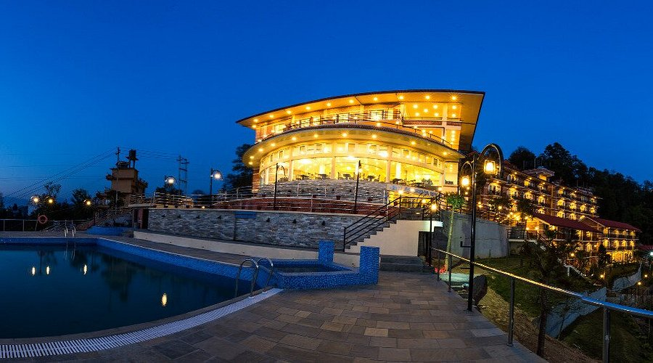
Figure 1: Himalaya Drishya Resort
Himalayan Drishya Hotel is a well-established hospitality organization located in the scenic town of Dhulikhel, Kavrepalanchok District, Nepal. Dhulikhel is widely known for its panoramic Himalayan views, peaceful environment, and rich cultural heritage. Due to its natural beauty and proximity to Kathmandu Valley, it has become one of the most popular tourist destinations for both domestic and international travelers. Himalayan Drishya Hotel plays a significant role in contributing to the tourism and hospitality sector of the region by offering quality accommodation, food and beverage services, and event facilities.
The hotel is designed to provide guests with a comfortable, relaxing, and memorable stay. It combines traditional Nepali hospitality with modern service standards to ensure guest satisfaction. The hotel offers well-furnished guest rooms with scenic mountain views, a multi-cuisine restaurant serving local and international dishes, conference and banquet halls for meetings and events, and various recreational facilities. The peaceful atmosphere of the hotel, along with its professional service culture, makes it an ideal destination for tourists, corporate guests, and event organizers.
The internship at Himalayan Drishya Hotel was undertaken as a partial fulfillment of the academic requirement of Bachelor in Hotel Management (BHM) under Pokhara University. The primary purpose of this internship was to gain practical exposure to hotel operations and to understand the real working environment of the hospitality industry. Hospitality education is not limited to theoretical classroom learning; it requires practical training to develop professional competence, communication skills, leadership qualities, and service excellence standards.
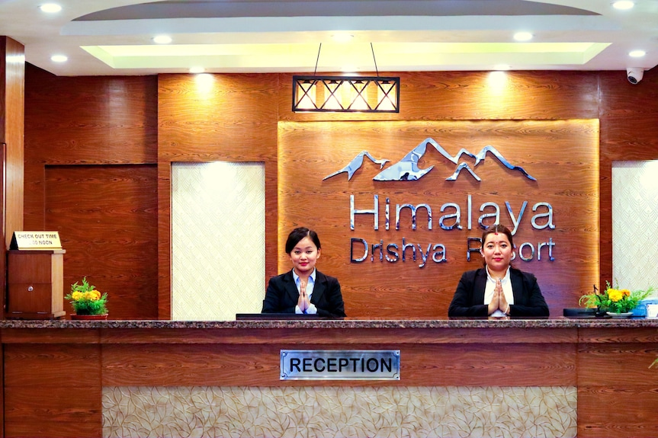
Figure 2: Himalaya Drishya Reception
During the internship period, exposure was gained in different operational departments such as Front Office, Housekeeping, Food and Beverage Service, and Kitchen. Each department plays a crucial role in maintaining the overall performance of the hotel. The Front Office department acts as the face of the hotel and is responsible for guest check-in, check-out, reservations, and guest relations. Housekeeping ensures cleanliness, hygiene, and maintenance of guest rooms and public areas. The Food and Beverage department focuses on providing quality dining experiences and event services, while the Kitchen department ensures food preparation standards and safety measures.
Himalayan Drishya Hotel maintains a structured organizational hierarchy to ensure smooth coordination among departments. Effective communication, teamwork, discipline, and service standards are strongly emphasized within the organization. The management focuses on delivering high-quality service while maintaining guest satisfaction and loyalty. The hotel also contributes to local employment opportunities and promotes tourism development in Dhulikhel.
The internship experience at Himalayan Drishya Hotel provided valuable insights into operational procedures, customer service management, complaint handling, and teamwork. Working in a real hospitality environment helped in understanding the challenges faced by the hotel industry, such as seasonal fluctuations, high guest expectations, and service pressure during peak seasons. These practical experiences enhanced professional confidence and prepared for future career opportunities in the hospitality sector.
In conclusion, Himalayan Drishya Hotel serves as an important hospitality establishment in Dhulikhel, offering quality services and maintaining professional standards. The internship conducted in this organization has been a significant milestone in academic and professional development. It has strengthened practical knowledge, improved interpersonal skills, and provided real-world exposure to hotel management operations.

Drishya Restaurant

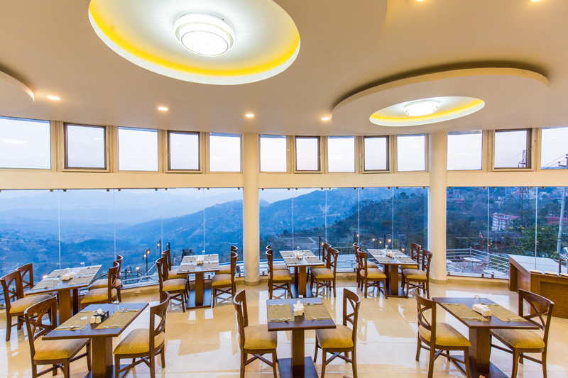
Figure 3: Drishya Restaurant

The Restaurant of Himalayan Drishya Hotel is one of the major operational departments of the hotel and plays a vital role in delivering quality food and beverage services to guests. The restaurant is designed to provide a comfortable and scenic dining experience, allowing guests to enjoy delicious meals while experiencing the beautiful panoramic view of the Himalayas.
The restaurant offers a wide variety of cuisines including traditional Nepali dishes, Indian cuisine, Continental items, and selected Chinese dishes. The menu is carefully designed to meet the preferences of both domestic and international guests. Fresh and locally sourced ingredients are used to maintain quality, hygiene, and taste standards. The restaurant operates for breakfast, lunch, and dinner services, and also provides special menus during festivals, events, and group bookings.
The seating arrangement of the restaurant is spacious and well-organized, ensuring comfort and privacy for guests. It can accommodate individual travelers, families, corporate groups, and event participants. The restaurant also provides banquet-style services for seminars, conferences, weddings, and other special occasions organized at the hotel.
The Food and Beverage Service department ensures proper mise-en-place, hygiene standards, and service sequence during operations. Staff members are trained to welcome guests warmly, present menus professionally, take orders accurately, and serve food following standard service procedures. Guest satisfaction is the top priority, and feedback is regularly collected to improve service quality.
During my internship period, I was involved in various restaurant operations such as table setting, order taking, serving food and beverages, coordinating with kitchen staff, and maintaining cleanliness standards. This experience helped me develop communication skills, teamwork ability, time management, and service professionalism.
In conclusion, the Drishya Restaurant is a core component of Himalayan Drishya Hotel, contributing significantly to guest satisfaction and overall hotel revenue. It reflects the hotel’s commitment to quality service and authentic hospitality.

Outdoor Pool Bar

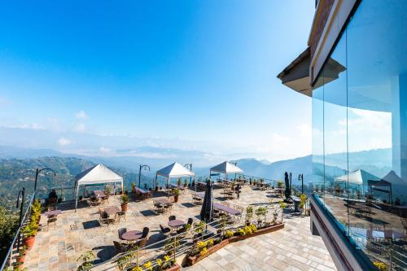
Figure 4: Outdoor pool bar

The Outdoor Pool Bar is an attractive and value-adding facility available at Himalayan Drishya Hotel. It is strategically located near the outdoor swimming pool area, allowing guests to enjoy refreshing beverages and light snacks while relaxing in a scenic environment. The pool bar enhances the resort experience by combining leisure, hospitality, and premium beverage service.
The primary function of the outdoor pool bar is to provide convenient food and beverage services to guests using the swimming pool and surrounding recreational area. The bar offers a variety of alcoholic and non-alcoholic beverages, including mocktails, cocktails, fresh juices, soft drinks, beer, wine, and specialty drinks. In addition to beverages, selected light snacks and finger foods are also served to meet guest preferences without requiring them to leave the poolside area.
The design and ambiance of the pool bar contribute significantly to the overall guest experience. The setup is casual yet elegant, maintaining a relaxed resort atmosphere. Comfortable seating arrangements, shaded umbrellas, and well-organized service counters create a welcoming and enjoyable environment. The open-air concept allows guests to enjoy natural surroundings while socializing with friends and family.
From an operational perspective, the pool bar follows standard food and beverage service procedures. Proper mise-en-place is conducted before service hours, ensuring that glassware, bar tools, beverage stock, and garnishes are prepared in advance. Hygiene and cleanliness are strictly maintained to ensure food safety and quality standards. Staff members are trained in customer service, beverage preparation, and responsible alcohol service practices.
The outdoor pool bar also contributes to the hotel’s revenue generation by increasing average guest spending. Guests spending time at the swimming pool are more likely to order beverages and snacks, which boosts the food and beverage department’s sales. During peak seasons, weekends, and special events, the pool bar becomes a lively social space that enhances the resort’s atmosphere.
During my internship period, I observed how the food and beverage team coordinated service operations at the pool bar, especially during busy hours. This experience provided insight into beverage service techniques, customer interaction, and stock management practices.
In conclusion, the outdoor pool bar is an important recreational and revenue-generating facility of Himalayan Drishya Hotel. It strengthens the resort’s image as a leisure destination and significantly enhances guest satisfaction by providing convenience, relaxation, and quality service in a scenic outdoor setting.

Gauri Shankar Ballroom

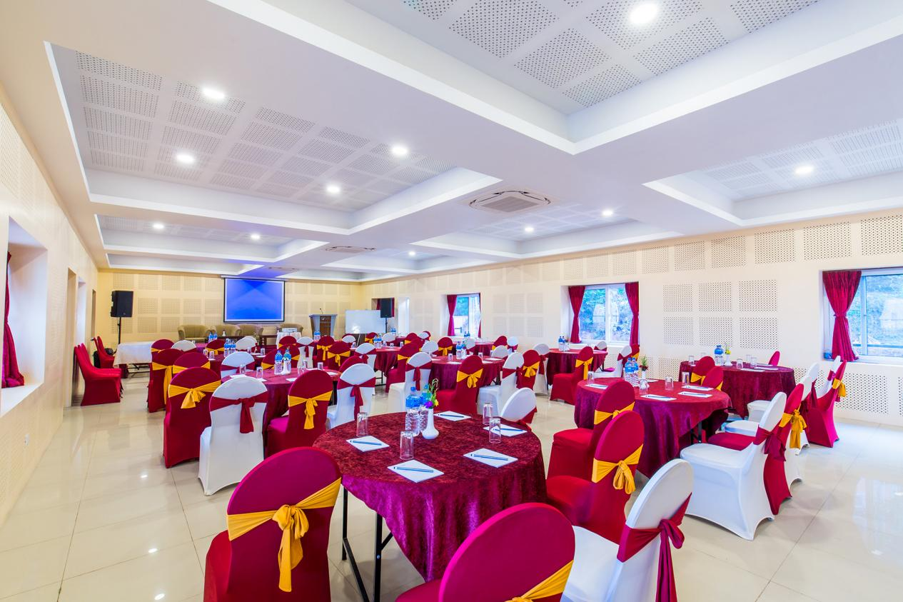
Figure 5: Gauri Shankar Ballroom

The Gauri Shankar Ballroom is one of the major event and banquet facilities available at Himalayan Drishya Hotel. Named after the majestic Gauri Shankar mountain, the ballroom reflects elegance, grandeur, and cultural significance. It is designed to host a variety of formal and social events, making it an essential revenue-generating department of the hotel.
The ballroom is spacious and well-equipped with modern facilities suitable for conferences, seminars, corporate meetings, weddings, receptions, training programs, and social gatherings. It has a large seating capacity and can be arranged in different layouts such as theater style, classroom style, U-shape, banquet style, and boardroom setup depending on the nature of the event. This flexibility allows the hotel to cater to different types of clients and occasions.
The Gauri Shankar Ballroom is supported by advanced audio-visual equipment including projectors, sound systems, microphones, lighting systems, and stage arrangements. Proper air-conditioning, lighting control, and decoration options enhance the overall atmosphere of the hall. The banquet team ensures that every event is well-coordinated from planning to execution.
The Food and Beverage department plays a crucial role in ballroom operations. Catering services such as buffet setup, plated service, coffee breaks, and customized menus are provided according to client requirements. Coordination between the banquet team, kitchen department, housekeeping, and technical staff ensures smooth event management and guest satisfaction.
The ballroom significantly contributes to the hotel’s income, especially during wedding seasons and corporate event periods. Large-scale events increase room occupancy, food and beverage sales, and overall brand visibility of the hotel. Many local and corporate clients prefer Himalayan Drishya Hotel due to its scenic location combined with professional banquet services.
During my internship, I observed banquet preparations, seating arrangements, buffet setup, and coordination among departments during events. This practical exposure enhanced my understanding of event management, teamwork, time management, and guest handling in a large-scale hospitality setting.
In conclusion, the Gauri Shankar Ballroom is a vital facility of Himalayan Drishya Hotel. It strengthens the hotel’s position as a resort and event destination while contributing significantly to its revenue and reputation in the hospitality market of Dhulikhel.

1.2 Organization Vision, Mission and Objectives

Vision
The vision of Himalayan Drishya Hotel is to become a leading resort destination in Dhulikhel and a preferred choice for both domestic and international travelers by providing exceptional hospitality services combined with natural scenic beauty. The hotel aims to establish a strong reputation for quality service, guest satisfaction, and sustainable tourism development in Nepal.
The organization envisions creating memorable experiences for guests by maintaining high service standards, modern facilities, and traditional Nepali hospitality values. It strives to position itself as a reliable and competitive hospitality brand within the regional tourism market.

Mission

The mission of Himalayan Drishya Hotel is to deliver high-quality accommodation, food and beverage services, and event facilities while ensuring maximum guest satisfaction. The hotel is committed to:
- Providing warm, friendly, and professional hospitality services.
- Maintaining cleanliness, hygiene, and safety standards at all times.
- Offering comfortable and scenic accommodation facilities.
- Ensuring efficient coordination among departments for smooth operations.
- Promoting local culture and tourism in Dhulikhel.

The hotel also focuses on creating a positive working environment for employees by encouraging teamwork, discipline, and continuous improvement in service quality.

Objectives

The major objectives of Himalayan Drishya Hotel are as follows:
- To ensure guest satisfaction by delivering consistent, high-quality service in all departments.
- To increase occupancy rate and revenue generation through effective marketing and service excellence.
- To maintain high hygiene and safety standards in accommodation, restaurant, pool, and banquet areas.
- To provide professional event management services through facilities like Gauri Shankar Ballroom.
- To promote sustainable tourism practices by respecting local culture and environment.
- To enhance employee performance and development through training and teamwork.
- To strengthen the hotel’s brand image in the hospitality industry of Dhulikhel and surrounding areas.
In conclusion, the vision, mission, and objectives of Himalayan Drishya Hotel reflect its commitment to excellence in hospitality service, customer satisfaction, and sustainable growth. These guiding principles help the organization maintain its standards and achieve long-term success in the competitive hospitality industry.

1.3 Organization Design and Structure

The organizational design and structure of Himalayan Drishya Hotel play a crucial role in ensuring smooth operation and effective coordination among departments. Organizational structure refers to the hierarchical arrangement of authority, responsibility, communication flow, and departmental functions within the hotel. A well-defined structure helps maintain discipline, efficiency, and accountability in daily operations.
Himalayan Drishya Hotel follows a functional organizational structure, where responsibilities are divided based on specialized departments. Each department operates under the supervision of a departmental head who reports to higher-level management. This system allows clear communication, proper delegation of duties, and systematic workflow across the organization.
At the top level of management is the General Manager (GM) or Hotel Manager, who is responsible for overall planning, decision-making, supervision, and strategic development of the hotel. The General Manager ensures that all departments operate efficiently and meet organizational goals.
Under the General Manager, the hotel is divided into the following major departments:
1. Front Office Department
This department acts as the face of the hotel. It is responsible for reservations, guest check-in and check-out, handling guest inquiries, billing, and maintaining guest relations. The Front Office Manager supervises receptionists and front desk staff to ensure smooth service delivery.
2. Housekeeping Department
The Housekeeping department ensures cleanliness, hygiene, and maintenance of guest rooms and public areas. It plays a vital role in maintaining hotel standards and guest satisfaction. The Executive Housekeeper supervises room attendants and cleaning staff.
3. Food and Beverage Department
This department includes the restaurant, outdoor pool bar, banquet services, and kitchen operations. It is responsible for food preparation, beverage service, event catering, and maintaining food hygiene standards. The Food and Beverage Manager coordinates restaurant supervisors, chefs, waiters, and bar staff.
4. Banquet and Event Department
The Gauri Shankar Ballroom operates under this section. It handles conferences, weddings, seminars, and social events. Coordination with the kitchen, housekeeping, and technical teams is essential for successful event execution.
5. Maintenance Department
This department ensures proper functioning of electrical systems, plumbing, air-conditioning, and other technical facilities. It supports all departments to maintain operational efficiency.
6. Accounts and Administration
The Accounts department manages financial records, budgeting, payroll, and cost control. Administrative functions ensure compliance with policies and regulations.
The organizational design emphasizes teamwork, inter-departmental coordination, and effective communication. Daily briefings and departmental meetings are conducted to discuss operational plans and address challenges. This structured approach ensures smooth service flow and enhances guest satisfaction.
In conclusion, the organizational design and structure of Himalayan Drishya Hotel provide a clear hierarchy of authority and responsibility. It promotes efficiency, accountability, and coordination, which are essential for delivering quality hospitality services and achieving organizational objectives.

1.4 Products and Services

The hospitality industry primarily focuses on delivering both tangible products and intangible services to satisfy guests’ needs and expectations. Products refer to physical facilities and amenities provided by the hotel, while services represent the experiences and assistance offered to guests during their stay. At Himalayan Drishya Hotel, both products and services are closely interconnected and play a significant role in maintaining quality standards and guest satisfaction.

1.4.1 Accommodation Services
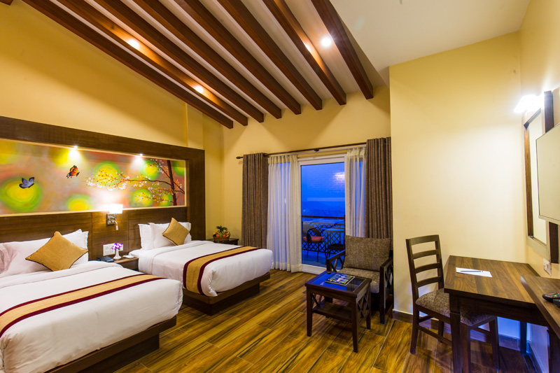
Figure 6: Accomodation
Accommodation is the core product of the hotel. Himalayan Drishya Hotel offers well-furnished and comfortable guest rooms with scenic views of the surrounding hills and Himalayan range. The rooms are equipped with essential facilities such as comfortable beds, attached bathrooms, hot and cold water supply, television, Wi-Fi connectivity, telephone service, and room service. The peaceful environment enhances the overall guest experience and ensures relaxation.
Different room categories are available to meet the preferences of various guests, including standard rooms, deluxe rooms, and family rooms. Cleanliness, hygiene, and maintenance are ensured by the housekeeping department to maintain high service standards.

1.4.2 Food and Beverage Services

The Food and Beverage (F&B) department is one of the major revenue-generating sections of the hotel. The Drishya Restaurant offers a wide range of cuisines including Nepali, Indian, Continental, and Chinese dishes. Breakfast, lunch, and dinner services are provided with professional service standards.
Additional F&B facilities include:
- Outdoor Pool Bar
- Banquet Catering Services
- Room Service
The hotel ensures proper food hygiene, quality ingredients, and customer satisfaction. Buffet services, à la carte menus, and customized menus for events are also available.

1.4.3 Banquet and Event Services

The Gauri Shankar Ballroom is an important product of the hotel. It is designed for hosting weddings, conferences, seminars, corporate meetings, and social gatherings. The hall is equipped with modern audio-visual systems, lighting arrangements, air conditioning, and flexible seating layouts.
Banquet services include buffet setup, plated service, decoration, event coordination, and technical support. This department significantly contributes to the hotel’s revenue.

1.4.4 Recreational Facilities

To enhance guest satisfaction, the hotel provides various recreational facilities such as:
- Outdoor Swimming Pool
- Outdoor Pool Bar
- Scenic Garden Area
- Relaxation Spaces
The outdoor swimming pool offers leisure and relaxation with proper safety and hygiene management. The poolside bar adds additional convenience and enjoyment for guests.

1.4.5 Additional Services

Besides major products, the hotel also provides supportive services such as:
- 24-hour Front Desk Service
- Free Wi-Fi Connectivity
- Parking Facility
- Laundry Service
- Housekeeping Services
- Security and Surveillance
- Event Coordination Support
These services enhance the overall guest experience and strengthen the hotel’s competitive position in the hospitality market.

1.5 Major Market and Customers

Understanding the major market and customer base is essential for the success of any hospitality organization. The target market refers to the specific group of customers that the hotel focuses on to generate revenue and maintain occupancy levels. At Himalayan Drishya Hotel, the major market consists of both domestic and international guests who seek a peaceful resort experience combined with scenic beauty and quality service.
1. Domestic Market
The domestic market forms a significant portion of the hotel’s customer base. Guests from Kathmandu Valley and other major cities of Nepal frequently visit Dhulikhel for short holidays, weekend getaways, family gatherings, and corporate retreats. The hotel attracts:
- Families seeking relaxation and recreation
- Couples and honeymoon guests
- Corporate groups for seminars and meetings
- Educational institutions for workshops and training programs
- Wedding and social event organizer
During festive seasons, wedding seasons, and holiday periods, domestic bookings increase significantly, contributing to higher occupancy rates and banquet revenue.
2. International Market
The international market includes tourists visiting Nepal for leisure, cultural exploration, trekking, and sightseeing. Dhulikhel is known for its panoramic Himalayan views and proximity to Kathmandu, making it a preferred destination for foreign travelers.
International guests mainly include:
- Tourists from Europe, America, and Asian countries
- Group travelers and travel agency bookings
- Adventure tourists exploring nearby trekking routes
- Cultural and spiritual tourists
International visitors often prefer hotels that provide scenic views, peaceful surroundings, and quality hospitality services, which makes Himalayan Drishya Hotel a suitable choice.
3. Corporate and Institutional Clients
Corporate clients represent an important segment of the hotel’s market. Companies and organizations book the hotel for:
- Conferences and seminars
- Training programs
- Team-building events
- Official meetings

The availability of facilities like Gauri Shankar Ballroom enhances the hotel’s attractiveness for corporate clients.
4. Event and Social Market
The banquet and event market is another major revenue source. Weddings, receptions, anniversaries, birthday celebrations, and social gatherings are regularly organized at the hotel. The scenic location and spacious ballroom make it a preferred venue for such occasions.
- Customer Characteristics
The typical customers of Himalayan Drishya Hotel include middle to upper-income groups who value comfort, scenic beauty, and quality service. Most guests expect:
- Clean and comfortable accommodation
- Professional and friendly service
- Quality food and beverage options
- Safe and peaceful environment
- Recreational facilities such as swimming pool and pool bar
The hotel focuses on maintaining guest satisfaction, building long-term relationships, and encouraging repeat visits through quality service and positive experiences.

Conclusion
The major market of Himalayan Drishya Hotel consists of domestic tourists, international travelers, corporate clients, and social event organizers. By targeting diverse customer segments and providing quality hospitality services, the hotel maintains its competitive position in the tourism market of Dhulikhel. Understanding customer expectations and delivering consistent service excellence are key factors in sustaining business growth.

1.6 Organization’s International Linkages

International linkages refer to the connections and partnerships that a hospitality organization establishes with global agencies, travel platforms, tour operators, and other business partners to expand its market reach. In today’s competitive hospitality industry, maintaining strong international connections is essential for attracting foreign guests and increasing global visibility.
Himalayan Drishya Hotel maintains international linkages primarily through online travel agencies (OTAs), travel agents, and digital marketing platforms. These connections help the hotel promote its services to a wider international audience and facilitate easier booking processes for foreign tourists.
1. Online Travel Agencies (OTAs)
The hotel is listed on several global booking platforms, which allow international guests to view room availability, compare prices, and make reservations easily. These platforms include:
- Booking.com
- Agoda
- Expedia
- TripAdvisor
- Airbnb (if applicable)
Through these platforms, guests from different countries can access detailed information about the hotel, including room types, facilities, photos, and customer reviews. Positive reviews and ratings on such platforms significantly improve the hotel’s reputation and credibility in the international market.
2. Travel and Tour Operators
Himalayan Drishya Hotel also collaborates with international and national travel agencies and tour operators. These agencies include the hotel in their tour packages for tourists visiting Kathmandu and nearby destinations such as Nagarkot and Dhulikhel. Group bookings arranged by travel companies contribute to stable occupancy rates.
3. Digital and Social Media Presence
The hotel maintains an online presence through social media platforms and official websites. This digital connection helps attract international travelers who search for scenic resort stays in Nepal. Online marketing plays a crucial role in building global awareness and brand recognition.
4. Contribution of International Linkages
International linkages provide several advantages to the hotel:
- Increase in foreign tourist arrivals
- Growth in occupancy rate and revenue
- Improved brand recognition
- Access to global customer reviews and feedback
- Expansion of business opportunities
By maintaining strong connections with international booking platforms and travel networks, the hotel enhances its competitiveness in the global tourism market.

CHAPTER 2 :INTEREST, SKILLS, ATTITUDE AND PLANNING

2.1 Intern’s Interest in Himalayan Drishya Hotel

The primary reason for choosing Himalayan Drishya Hotel for internship was its reputation as a well-established resort property in Dhulikhel. The hotel is known for its scenic location, professional service standards, banquet facilities, outdoor pool, and restaurant services. Being located in a tourist destination, it provided an excellent opportunity to gain exposure to both domestic and international guests.
Another important reason for selecting this organization was the availability of multiple operational departments such as Front Office, Food and Beverage Service, Banquet, Pool Bar, and Housekeeping. This diversity allowed broader learning opportunities and practical exposure to real hotel operations. The peaceful resort environment combined with professional hospitality services made it an ideal training ground for developing industry skills.

2.2 Intern’s Interest in Food and Beverage Service Department

Among all departments, the Food and Beverage (F&B) Department attracted the most interest. This department directly interacts with guests and significantly contributes to revenue generation. It includes Drishya Restaurant, Outdoor Pool Bar, Banquet Services (Gauri Shankar Ballroom), and Room Service operations.
The main reasons for choosing the F&B department were:
- Opportunity to interact directly with guests
- Learning professional service sequence
- Developing communication and customer handling skills
- Gaining practical knowledge of restaurant and banquet operations
- Understanding beverage preparation and service standards

Working in this department provided exposure to mise-en-place preparation, order taking, serving techniques, buffet setup, banquet coordination, and handling guest feedback.

2.3 Intern’s Skills Developed During Internship

During the internship period, both practical and soft skills were significantly improved.
A. Practical Skills
- Proper table setting and service sequence
- Buffet setup and banquet arrangement
- Beverage preparation (tea, coffee, mocktails, soft drinks)
- Order taking and billing coordination
- Guest complaint handling
- Maintaining hygiene and cleanliness standards
- Coordination between kitchen and service team
- Basic inventory and stock management
B. Soft Skills
- Communication skills
- Teamwork and cooperation
- Time management
- Leadership qualities
- Problem-solving ability
- Confidence in handling guests
- Working under pressure
These skills enhanced professional competence and prepared for future career growth in the hospitality sector.

2.4 Intern’s Attitude

Attitude plays a crucial role in hospitality. Throughout the internship, maintaining professionalism, discipline, and positive behavior was prioritized. The hospitality industry demands patience, politeness, and customer-oriented thinking.
Important professional attitudes maintained during the internship include:
- Respect towards seniors and colleagues
- Maintaining personal hygiene and grooming standards
- Being punctual and disciplined
- Willingness to learn and adapt
- Maintaining honesty and integrity
- Showing cooperation with other departments
Working in a real hotel environment strengthened the understanding that teamwork and positive attitude are essential for delivering quality service.

2.5 Planning and Expected Outcomes

Before starting the internship, clear objectives and expectations were established. The main planning goals were:
- To gain real-world operational knowledge
- To improve communication and customer handling skills
- To understand hotel management structure
- To develop leadership and teamwork qualities
- To prepare for future employment in hospitality industry
The expected outcome of the internship was to bridge the gap between theoretical knowledge and practical experience. After completing the training period, a better understanding of hotel operations, guest expectations, and service excellence was achieved.

2.6 SWOT Analysis of Food and Beverage Department

A SWOT analysis is a strategic tool used to evaluate the Strengths, Weaknesses, Opportunities, and Threats of an organization or department. It helps in understanding internal capabilities and external challenges that affect performance. The Food and Beverage (F&B) Department of Himalayan Drishya Hotel plays a crucial role in revenue generation and guest satisfaction. The SWOT analysis of the department is presented below:
Strengths
Strengths are the internal factors that provide competitive advantage to the department.
- Scenic dining experience with Himalayan view
- Well-equipped restaurant, pool bar, and banquet facilities
- Professional and cooperative service staff
- Strong coordination between kitchen and service team
- Quality food and hygiene standards
- Flexible banquet setup for weddings and corporate events
- Attractive outdoor pool bar facility
The presence of Drishya Restaurant and Gauri Shankar Ballroom significantly enhances the department’s market value and brand image.

Weaknesses
Weaknesses are internal limitations that may reduce efficiency or performance.
- Limited advanced beverage equipment compared to luxury hotels
- Seasonal fluctuation in customer flow
- Limited international menu variety
- Occasional shortage of trained manpower during peak seasons
- Limited marketing focus on pool bar and banquet services
These weaknesses can be minimized through better planning, staff training, and marketing strategies.
Opportunities
Opportunities are external factors that the department can utilize for growth.
- Growing tourism in Dhulikhel area
- Increasing demand for destination weddings and corporate retreats
- Expansion of online promotion and digital marketing
- Introducing theme nights and special dining events
- Collaboration with travel agencies and tour operators
- Increasing domestic tourism after pandemic recovery
By focusing on innovative services and marketing strategies, the F&B department can increase revenue and brand recognition.

Threats
Threats are external challenges that may affect the department negatively.
- Increasing competition from nearby resorts and hotels
- Price competition in the local market
- Economic fluctuations affecting tourism
- Changing customer preferences
- Food cost inflation and supply chain issues
Proper strategic planning and service quality improvement can help minimize these risks.

2.7 Expected Outcomes

The internship at Himalayan Drishya Hotel was undertaken with clear expectations and learning objectives. The primary expected outcome was to gain practical exposure to real hotel operations and to bridge the gap between theoretical knowledge gained in classroom studies and practical implementation in the hospitality industry.
One of the major expected outcomes was to develop professional competence in the Food and Beverage Department. This included learning proper service sequence, mise-en-place preparation, buffet setup, banquet coordination, and beverage service techniques. By actively participating in daily operations, it was expected to build confidence in handling guests, managing service pressure, and maintaining hygiene standards.
Another important expected outcome was to improve communication skills and interpersonal abilities. The hospitality industry requires constant interaction with guests from diverse backgrounds, cultures, and expectations. Therefore, improving verbal communication, body language, customer handling skills, and problem-solving abilities was a key objective of the internship.
Leadership and teamwork development were also major expectations. Working in coordination with different departments such as kitchen, housekeeping, front office, and banquet management was expected to enhance teamwork skills and professional discipline. Understanding departmental coordination and organizational hierarchy was essential for future managerial roles.
Additionally, the internship aimed to develop time management skills, adaptability, and the ability to work under pressure. The hospitality industry often involves long working hours and high service demand, especially during peak seasons and events. Therefore, gaining the ability to remain calm and efficient under pressure was an important learning goal.
Finally, the long-term expected outcome was career preparation. The internship was intended to provide real-world industry exposure, helping in identifying strengths and areas for improvement. It was expected to enhance employability, professional confidence, and readiness to enter the hospitality workforce after completing the BHM degree.

CHAPTER 3 :SUMMARY AND CONCLUSION

3.1 Summary

This internship report presents a comprehensive overview of the practical training completed at Himalayan Drishya Hotel as part of the Bachelor in Hotel Management (BHM) program under Pokhara University. The internship provided valuable exposure to real-world hospitality operations and allowed the application of theoretical knowledge in a practical environment.
During the internship period, training was primarily undertaken in the Food and Beverage Department, including Drishya Restaurant, Outdoor Pool Bar, and Gauri Shankar Ballroom banquet operations. The experience involved participation in daily service operations such as mise-en-place preparation, order taking, food and beverage service, banquet setup, and coordination with kitchen staff. Exposure to these operational activities enhanced understanding of service standards, hygiene practices, and customer satisfaction principles.
The internship also provided insight into the organizational structure, mission, vision, and operational management of the hotel. The experience demonstrated how various departments such as Front Office, Housekeeping, Maintenance, Accounts, and Food and Beverage coordinate to ensure smooth service delivery. The integration of accommodation services, restaurant facilities, banquet halls, outdoor recreational amenities, and pool bar services contributes significantly to guest satisfaction and revenue generation.
Throughout the training period, practical and soft skills were developed. Practical skills included table setup, beverage service, buffet arrangement, guest handling, and basic inventory management. Soft skills such as communication, teamwork, leadership, time management, discipline, and adaptability were significantly improved. Working under supervision in a professional hospitality environment helped build confidence and professional attitude.
The internship also highlighted the importance of service quality, guest feedback, and teamwork in maintaining hotel reputation. Observing operational challenges such as seasonal fluctuations, high guest expectations, and service pressure provided realistic insight into the hospitality industry.

3.2 Conclusion

Internships play a vital role in hospitality education by bridging the gap between theoretical study and practical application. The internship at Himalayan Drishya Hotel was a valuable learning experience that contributed significantly to professional and personal development. It provided real-world exposure to hotel management practices, customer service standards, and departmental coordination.
The experience strengthened understanding of how hospitality organizations operate in a competitive tourism market. It emphasized the importance of discipline, teamwork, hygiene standards, guest satisfaction, and professional conduct. The training period enhanced confidence in handling guests, managing service pressure, and working effectively within a team environment.
In conclusion, the internship has successfully achieved its objectives by providing practical knowledge, industry exposure, and skill development necessary for a future career in hotel management. The experience gained during this period will serve as a strong foundation for professional growth and long-term success in the hospitality industry.

